Nhóm 1 :

Bài 1 :

LPS array for "ABAABCABAABCB":

Index: 0 1 2 3 4 5 6 7 8 9 10 11 12

Pattern: A B A A B C A B A A B C B

LPS: 0 0 1 1 2 0 1 2 3 4 0 1 0

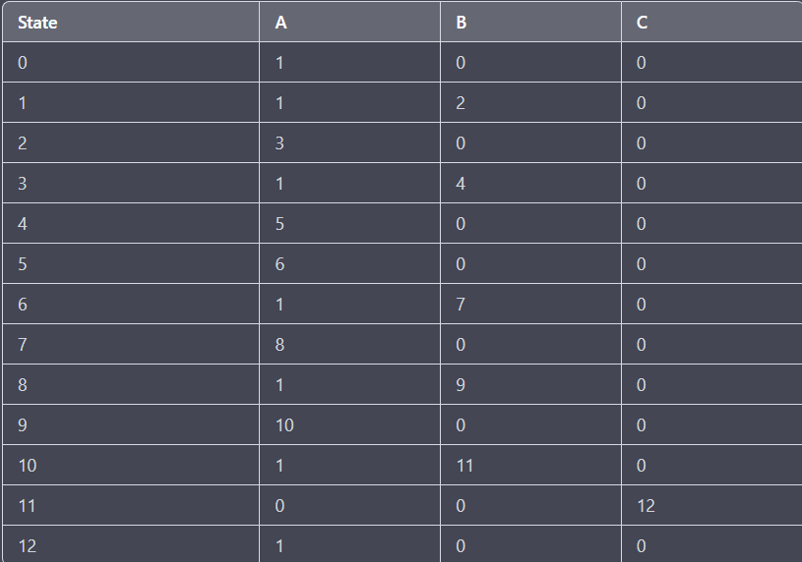

Bài 2 :

right[] = [0, 9, 4, 6, -1, -1, -1, 8, -1, -1, 10, -1, -1, -1, -1, -1, -1, -1, -1, -1, -1, -1, -1, -1, -1, -1]